Title of Work

Automated Attack Planning with Attack Graphs
A detailed project report on building an automated, graph-backed security planning framework that converts authorized scan evidence into ranked attack paths, validates planner behavior, and presents results through metrics and visuals.

Abstract
What: This work presents Automated Attack Planning with Attack Graphs, a software system that transforms discovered hosts, services, vulnerabilities, privileges, and exploit transitions into a structured attack graph. The graph represents reachable assets and possible movement paths so that a planner can reason over sequences of actions rather than isolated vulnerability entries.
Why: Traditional security assessment workflows often begin with scan results, but the analyst still has to decide how vulnerabilities chain across hosts and which route is most useful to test. As networks grow, it becomes harder to compare a fast direct path against a quieter alternative or explain why one route should be prioritized. The two reference papers reinforce this need: Wang et al. show the value of online planning for red-team testing, and Incalmo shows how high-level planning and expert execution agents can support multi-host operations.
How: The project combines Nmap parsing, CVE enrichment, graph construction, A* search, LLM-guided planning, reinforcement learning, detection-aware Pareto planning, controlled execution adapters, IDS-cost feedback, evaluation metrics, and visual reporting. This makes the system useful not only for finding a path, but also for comparing path length, detection exposure, and runtime behavior on repeatable benchmarks.

Problem Statement
Organizations often receive vulnerability scan outputs as lists of open ports, service versions, and CVE identifiers. These lists are helpful, but they do not directly answer a more important operational question: which sequence of actions could move an attacker from an initial foothold to a critical target, and what trade-offs exist between speed, reliability, exploitability, and detection exposure?
The core problem is the gap between raw vulnerability evidence and explainable attack-path planning. A flat vulnerability list may show that several services are risky, but it does not show whether those services create a reachable chain, which intermediate hosts matter, or whether a shorter route is also noisier from a defender's perspective.
This project addresses that gap by building a unified workflow that converts discovery evidence into graph state, compares planning strategies over the same graph, models execution as controlled playbook actions, and evaluates outcomes using measurable metrics. The result is a defensible planning artifact that can support red-team preparation, defensive validation, and remediation prioritization in authorized lab settings.
Core challenge
The project bridges three layers that are often separated: vulnerability modeling, automated planning, and operational feedback. Without that bridge, a plan may be theoretically shortest but operationally noisy, or visually impressive but disconnected from executable steps.

Objective 1:

Construct a high-fidelity attack graph
The first objective is to convert network discovery evidence into a graph that is rich enough for planning. The graph must represent hosts, services, vulnerabilities, exploitability, privileges, and directed movement between assets. In this implementation, the graph layer parses Nmap XML, enriches discovered services with CVE context, and creates reusable entities that planners and visualizers can consume.
The graph representation is important because it turns disconnected facts into relationships. A vulnerable service becomes more useful when it is tied to a host, a privilege change, an exploit transition, and a target objective. That structure is what allows A*, LLM-guided reasoning, RL, and detection-aware planners to operate on the same environment.
- Discovery ingestion: parse Nmap XML and normalize host, service, port, and version evidence into a consistent inventory.
- Vulnerability context: enrich services with CVE identifiers, severity values, exploit hints, and cached lookup data.
- Graph persistence: model hosts, services, vulnerabilities, privileges, and transitions so graph state can be reused for planning, evaluation, and visualization.

Objective 2:

Implement and compare multiple planning strategies
The second objective is to avoid dependence on a single planning method. A direct shortest-path planner may be fast, but it can miss stealthier routes. An LLM planner may provide strategic reasoning, but it needs graph grounding. Reinforcement learning can model policy-style path selection, but it needs comparison against deterministic baselines. Detection-aware planning provides a way to evaluate routes by expected visibility, not only by path length.
The project therefore compares A*, LLM-guided, RL, and detection-aware approaches on shared graph inputs. This matters because planner outputs can be judged using common metrics: path length, detection cost, runtime, and whether the route reaches the target. The comparison makes the planning behavior easier to explain and easier to improve.
- A*: provides a fast heuristic baseline for short, direct paths.
- LLM-guided planner: explores high-level strategy while still depending on graph-valid state.
- Reinforcement learning: tests policy-style route choices through the attack environment.
- Detection-aware planner: uses IDS cost and Pareto-style trade-offs to surface quieter routes.

Objective 3:

Execute, monitor, and evaluate attack plans
The third objective is to connect planning to an execution-aware and evaluation-ready workflow. The executor layer maps selected graph actions into playbook-oriented operations and adapter calls, while the detection layer estimates IDS exposure and supports replanning when a route becomes too noisy.
This objective keeps the system practical. A graph path is useful only if it can be interpreted as a controlled sequence of actions and evaluated after execution. The implementation therefore includes PlaybookRunner-style orchestration, adapters for Metasploit, SSH, and CALDERA-style actions, detection-cost modeling, metrics reporting, log collection, and visualization outputs.
- Controlled execution: represent selected path steps as lab-safe playbook operations and adapter calls.
- Runtime feedback: use IDS monitoring, detection cost, and replanning triggers to adjust route choice.
- Evaluation: report path length, detection cost, runtime, planner behavior, and graph visuals for analyst review.

Scope of Work
The scope of this project is the design, implementation, and evaluation of an automated attack-planning workflow for authorized lab networks. It includes scan parsing, CVE enrichment, attack-graph construction, planner comparison, controlled execution abstractions, detection-aware scoring, benchmark evaluation, and professional report generation.
The project is intentionally framed for defensive validation, education, and security research. It does not attempt to build a general-purpose offensive tool for uncontrolled environments, replace human red-team judgement, or prove universal optimality across every possible enterprise topology.
Input scans and benchmark data are assumed to represent authorized environments with known goals. Planner quality is evaluated on repeatable benchmark graphs and explicit cost functions. Human review remains responsible for authorization, interpretation, remediation decisions, and risk acceptance.
- In scope: graph-backed planning, planner comparison, detection-cost analysis, benchmark reporting, and visualization.
- Out of scope: unauthorized exploitation, third-party deployment, or autonomous action outside a controlled lab.
- Assumption: the planner assists defensive assessment; it does not replace analyst responsibility.

Existing approaches and gaps/improvement areas(min 3)
The existing work can be grouped into four useful families. Each contributes something valuable, but each also leaves an improvement area that this project addresses through scan-derived graph state, multi-planner comparison, execution awareness, and detection-cost evaluation.
Existing approach | Strength | Gap / improvement area | Project response
Classical attack graphs | Represent reachability, dependencies, and attack paths well. | Often remain static or require heavy manual modeling before planning. | Builds graph objects from scan evidence and CVE enrichment, then feeds them directly to planners and visuals.
Wang et al. 2024 STRIPS / partial-order planning [1] | Formalizes attack actions, preconditions, ordering, and online adjustment after feedback. | Focused on post-penetration planning; less emphasis on comparing graph, LLM/RL, and detection-aware planners together. | Keeps planning explicit while adding planner diversity, benchmark comparisons, and IDS-cost-aware route selection.
Incalmo LLM-assisted multi-host red teaming [2] | Separates high-level planning from expert task-agent execution and auxiliary services. | LLM-centric systems still need grounded state, controlled execution boundaries, and defender visibility modeling. | Uses graph state as the planning substrate and includes detection-aware evaluation rather than relying only on language context.
RL / MDP autonomous penetration testing | Can learn route choices from reward signals and repeated interaction. | Policies may be opaque, slow to train, and difficult to compare with deterministic baselines. | Reports RL beside A*, LLM-guided, and detection-aware routes using shared benchmark metrics.

Novelty/Innovativeness in Project
The novelty is not that attack graphs, automated red-team planning, LLM support, or reinforcement learning are individually new. The project-level innovation is the integration of these ideas into a single reproducible framework that starts with scan evidence and ends with planner comparison, detection-aware scoring, executable abstractions, and visual reporting.
This is valuable because many systems stop at one layer: a graph visualizer, a planner, a language-agent prototype, or an execution framework. This project joins those layers so that planning choices can be explained against concrete graph facts and measured against the same benchmark data.
- Planner diversity on one graph: A*, LLM-guided, RL, and detection-aware planners use the same graph representation.
- Detection as a first-class cost: plans are judged by defender visibility as well as reachability and path length.
- Execution-aware modeling: selected paths can be interpreted as controlled playbook and adapter actions.
- Benchmark-backed visuals: graph routes and trade-off charts make results inspectable instead of purely narrative.
- Ethical defensive framing: the workflow is scoped to authorized lab, education, and defensive evaluation contexts.
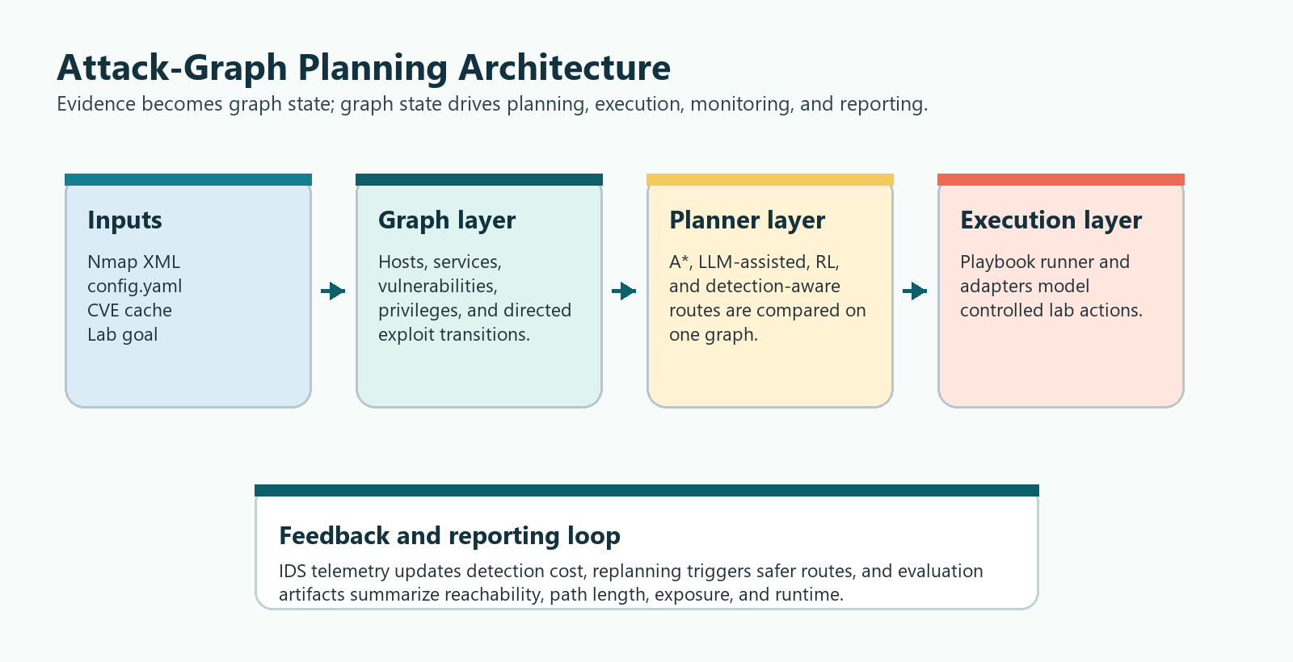
Figure 1. Integrated architecture for graph construction, planning, execution, monitoring, and evaluation.

Proposed Method
The proposed method treats attack planning as a measurable graph-search and decision problem. Instead of presenting vulnerabilities as a flat list, the workflow creates a typed graph, assigns costs to transitions, and allows multiple planners to produce comparable routes. The selected route can then be translated into controlled playbook steps and re-evaluated if detection signals change.
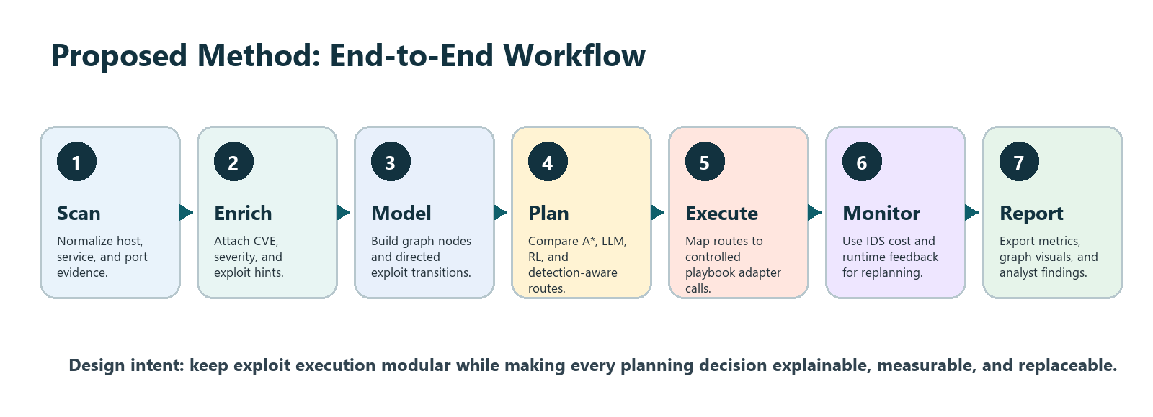
Figure 2. Proposed end-to-end method from scanning to reporting.
1. Collect authorized scan data and configuration inputs for the lab network.
2. Normalize host, service, port, and version data into a common inventory.
3. Enrich inventory items with CVE metadata, severity, exploitability hints, and cached vulnerability context.
4. Construct attack-graph nodes and directed transitions that encode prerequisites, reachable privileges, and target assets.
5. Run A*, LLM-guided, RL, and detection-aware planners over the same graph so route differences are attributable to planning strategy.
6. Apply detection cost and monitoring feedback to compare direct paths against quieter alternatives.
7. Export metrics, visuals, and analyst-readable explanations to support validation and remediation planning.

Implementation and Result
The implementation is organized as a modular Python codebase. The graph layer handles Nmap parsing, CVE enrichment, graph entities, and persistence-oriented data structures. The planning layer includes A*, LLM, RL, detection-aware, and Pareto-style logic. The executor layer models playbook execution and adapters for Metasploit, SSH, and CALDERA-style actions. Detection modules provide IDS monitoring, detection-cost scoring, and replanning triggers, while evaluation and visualization modules generate metrics, logs, graph outputs, and dashboard-ready artifacts.
The repository currently contains 42 Python files and 7 Python test files when virtual environment, Git metadata, and caches are excluded. The latest test run completed successfully with 44 passing tests. The only reported warnings are four deprecation warnings caused by timezone-naive UTC usage in the CVE enrichment layer; those are cleanup items rather than functional failures.

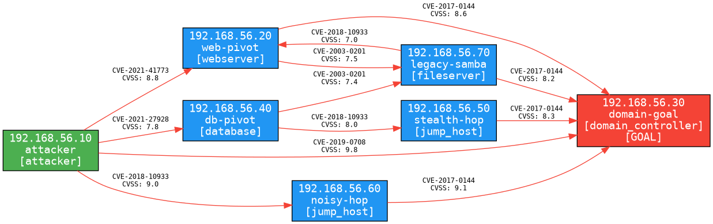
Figure 3. Complex benchmark full graph generated from project visualization outputs.
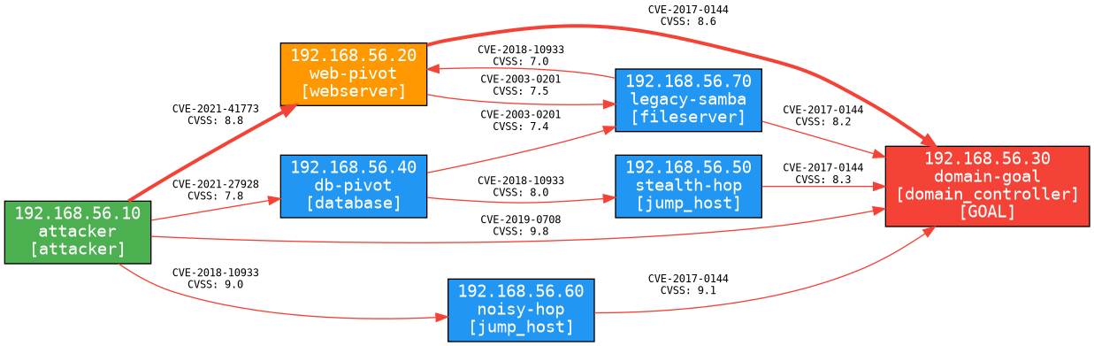
Figure 4. Detection-aware combined route on the complex benchmark.
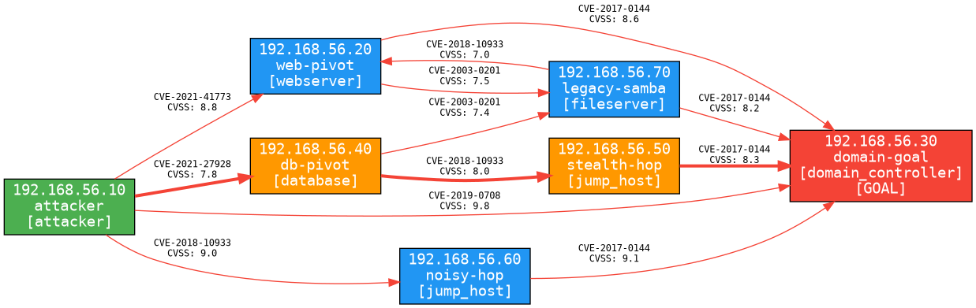
Figure 5. Detection-aware stealthiest route on the complex benchmark.
Benchmark | Planner / route | Steps | Detection cost | Runtime / note
Complex: 7 hosts, 12 edges | A*, LLM, RL direct route | 1 | 0.95 | Shortest route via CVE-2019-0708.
Complex: 7 hosts, 12 edges | Detection-aware combined | 2 | 0.40 | Balances route length and visibility.
Complex: 7 hosts, 12 edges | Detection-aware stealthiest | 3 | 0.18 | Lowest exposure route in this benchmark.
Huge: 600 devices, 1,597 edges | A* | 6 | 5.70 | 0.0662 ms average.
Huge: 600 devices, 1,597 edges | LLM offline | 6 | 5.70 | 3.253 ms average.
Huge: 600 devices, 1,597 edges | Detection combined | 11 | 1.54 | 0.4248 ms average.
Huge: 600 devices, 1,597 edges | RL seeded | 11 | 1.54 | 0.1671 ms average.
Huge: 600 devices, 1,597 edges | Detection stealthiest | 13 | 0.26 | 86.2081 ms mean Pareto-set computation.

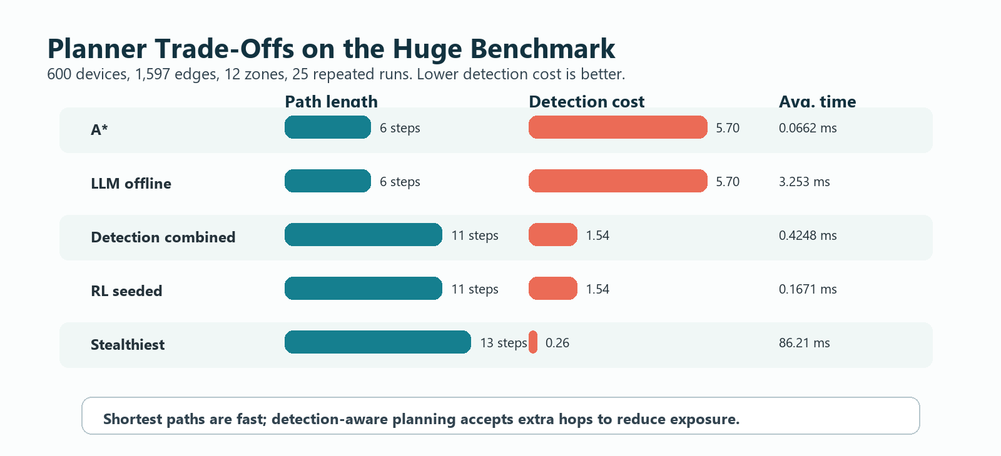
Figure 6. Planner trade-off visualization for the huge benchmark.
The results show a clear trade-off. Direct planners find shorter routes quickly, but those routes may have high detection cost. Detection-aware planning deliberately accepts extra hops to reduce expected exposure. In the huge benchmark, A* finds a 6-step route with detection cost 5.70, while the stealthiest route uses 13 steps but reduces detection cost to 0.26. This demonstrates the value of comparing path quality across multiple objectives rather than assuming the shortest path is always the most useful.
Result interpretation
The main practical value of the graph-backed approach is that defenders can see not only whether a path exists, but what kind of operational risk the path carries. This supports better prioritization for patching, segmentation, credential hardening, and detection tuning.

Conclusion
The project successfully demonstrates a complete attack-graph planning workflow. Scan evidence is normalized, enriched, converted into graph structures, planned over by multiple strategy families, and evaluated with both path and detection metrics. The final system is more than a visualization; it is an analysis pipeline that compares planning assumptions and shows the consequences of choosing speed over stealth or vice versa.
The implementation aligns with current research directions in automated red-team planning and LLM-assisted multi-host red teaming, while staying grounded in structured graph state, repeatable benchmarks, and defensive evaluation. The benchmark results confirm that the same attack graph can support direct, combined, and stealth-oriented routes, making it easier for analysts to reason about exposure and remediation priorities.

Future Work
- Replace timezone-naive UTC calls in the enrichment layer with timezone-aware UTC objects.
- Expand benchmark scenarios with more heterogeneous services, credential relationships, privilege-escalation chains, and segmented enterprise-style topologies.
- Improve defender models by adding alert coverage, sensor placement, response time, adaptive blocking, and alert fatigue.
- Strengthen LLM planner guardrails by constraining suggestions to graph-valid actions and explaining rejected actions.
- Integrate remediation recommendations so each high-risk path maps to patching, segmentation, credential hardening, or detection-control improvements.
- Automate report generation from benchmark outputs so future experiments can update tables and figures without manual editing.

References
1. Wang, Z., Li, S., Zhang, L., Hu, C., and Yan, L. (2024). A Red Team automated testing modeling and online planning method for post-penetration. Computers & Security, 144, 103945. https://doi.org/10.1016/j.cose.2024.103945
2. Singer, B., Lucas, K., Adiga, L., Jain, M., Bauer, L., and Sekar, V. (2025). Incalmo: An Autonomous LLM-assisted System for Red Teaming Multi-Host Networks. arXiv:2501.16466v4. https://arxiv.org/html/2501.16466v4
3. Ammann, P., Wijesekera, D., and Kaushik, S. (2002). Scalable, graph-based network vulnerability analysis. Proceedings of the 9th ACM Conference on Computer and Communications Security, 217-224. https://doi.org/10.1145/586110.586140
4. Ou, X., Govindavajhala, S., and Appel, A. W. (2005). MulVAL: A logic-based network security analyzer. Proceedings of the 14th USENIX Security Symposium, 113-128. https://www.usenix.org/event/sec05/tech/ou.html
5. Applebaum, A., Miller, D., Strom, B., Korban, C., and Wolf, R. (2016). Intelligent, automated red team emulation. Proceedings of the 32nd Annual Conference on Computer Security Applications, 363-373. https://doi.org/10.1145/2991079.2991111
6. Alford, R., Lawrence, D., and Kouremetis, M. (2022). CALDERA: A red-blue cyber operations automation platform. ICAPS 2022 Demonstrations. https://icaps22.icaps-conference.org/demos/ICAPS_2022_paper_375.pdf
7. Phillips, C., and Swiler, L. P. (1998). A graph-based system for network-vulnerability analysis. Proceedings of the 1998 Workshop on New Security Paradigms, 71-79. https://doi.org/10.1145/310889.310919
8. Sheyner, O., Haines, J., Jha, S., Lippmann, R., and Wing, J. M. (2002). Automated generation and analysis of attack graphs. Proceedings of the IEEE Symposium on Security and Privacy, 273-284. https://doi.org/10.1109/SECPRI.2002.1004377
9. Obes, J. L., Sarraute, C., and Richarte, G. (2013). Attack planning in the real world. arXiv:1306.4044. https://arxiv.org/abs/1306.4044
10. Sarraute, C., Buffet, O., and Hoffmann, J. (2013). POMDPs make better hackers: Accounting for uncertainty in penetration testing. arXiv:1307.8182. https://arxiv.org/abs/1307.8182
11. Hoffmann, J. (2015). Simulated penetration testing: From Dijkstra to Turing Test++. Proceedings of the 25th International Conference on Automated Planning and Scheduling. https://publications.cispa.saarland/1127/
12. Hart, P. E., Nilsson, N. J., and Raphael, B. (1968). A formal basis for the heuristic determination of minimum cost paths. IEEE Transactions on Systems Science and Cybernetics, 4(2), 100-107. https://doi.org/10.1109/TSSC.1968.300136
13. Sutton, R. S., and Barto, A. G. (2018). Reinforcement Learning: An Introduction, 2nd ed. MIT Press. https://mitpress.mit.edu/9780262352703/reinforcement-learning/
14. Schwartz, J., and Kurniawati, H. (2019). Autonomous penetration testing using reinforcement learning. arXiv:1905.05965. https://arxiv.org/abs/1905.05965
15. Lyon, G. F. (2009). Nmap Network Scanning: The Official Nmap Project Guide to Network Discovery and Security Scanning. Nmap Project. https://nmap.org/book/
16. National Institute of Standards and Technology. (n.d.). National Vulnerability Database. https://www.nist.gov/programs-projects/national-vulnerability-database-nvd
17. MITRE. (n.d.). MITRE ATT&CK: Adversarial Tactics, Techniques, and Common Knowledge. https://attack.mitre.org/
18. Project repository implementation artifacts inspected locally: graph, planners, executor, detection, rl, evaluation, visualization, tests, and benchmark outputs.

